Name:
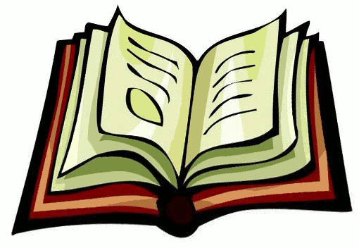

World History Patterns of Interaction:
Textbook Scavenger Hunt

Introduction: How to Read a History Textbook

Instead of jumping in and tackling your initial reading assignment, try to get a feel for the book first. Look over the table of contents and glance through the chapters to see how the authors chose to organize the material. You'll notice that each chapter is divided into smaller sections, which makes note-outlining easier. Each chapter begins with a preview of the content and a timeline to help us better understand the context of the material. Both are useful study aids. Next, read a chapter or two from different time periods to familiarize yourself with the author’s writing style and their presentation of the information. Pay close attention when the author discusses the causes and effects of historical events, points out different interpretations of information, and makes comparisons between one time period and another. Do not overlook the maps, charts, graphs, and pictures that the author chooses to include in each section – these are often just as informative as the text! Ultimately, knowing how to use your textbook can be one of the greatest tools in helping you to succeed in this - or any - class!

Activity: Getting to Know Your Textbook

Directions: Read and answer the questions below.

- The introductory pages viii – xvi make up the textbook’s Table of Contents. Flip through these pages. Which unit are you most interested in learning about this year? Why?

- Examine the maps on pages A1 – A47. Use these maps to answer the questions below.

A. Using the Legend (Key) on page A1, draw the symbol for a National Capital here:

B. Using the Legend (Key) on page A1, draw the symbol for a River here:

C. Using the Legend (Key) on page A1, draw the symbol for a Mountain Peak and the Highest Mountain Peak here:

D. Look at the political map of Africa on page A16 and the physical map of Africa on page A17. Based on your observations, what do you think the difference is between a political map and a physical map?

- Pages 282 – 296 are an excellent resource for reviewing what big idea?

- In the space below, list the six topics described on pages 284 – 295.

- Look at the images of The Dome of the Rock found on page 266. Then, answer the questions below.

A. How is The Dome of the Rock similar to other religious buildings you have seen?

B. How is The Dome of the Rock different from other religious buildings you have seen?

C. Why might the author of a History textbook include pictures, like those on page 266, in each chapter?

- Look on page 78. What is the meaning of Monotheism and Covenant? What did the author do that helped you to explain these terms?

- What information can you find on pages R76 – R91? What is the purpose of this section?

- How is the information found on pages R92 – R106 similar to the information found on pages R76 – R91? How is it different?

- How might the information found on pages R107 – R134 help you to complete a reading assignment?

